Optimising Faith-Driven Operations: Process Redesign and Digital Transformation Proposal for FaithWorks

Author

Saraf Rahman Khan - 110438694

# Executive Summary

FaithWorks-Food Assist is a volunteer-run food relief store that converts recycled donated food into affordable meals for about 180-200 vulnerable families every day alongside offering other necessary goods at a discounted price. The current operation covers transportation, sorting, storage, meal preparation services, and customer service and checkout. However, most of the operating specifications are only verbally taught to the staff, relying on manual records, and the process lacks standardization and data support.

This study uses the BPM lifecycle method to conduct AS-IS modeling and TO-BE design for the two main processes of Categorical Sorting & Storage of Inventory and Customer Service and checkout process. The core of the improvement plan includes: introducing barcode inventory management and lightweight cloud POS (supporting member scanning and automatic billing, and discount calculation), converting key operations into standardized workflows. It is expected to reduce manual decision nodes, shorten the average customer waiting time, and generate real-time operating data, laying the foundation for continuous improvement.

It is recommended to pilot the above digital tools on a small scale first, gradually solidify the institutionalized process, and consolidate the improvement results through periodic performance reviews. This solution has low investment costs, conforms to the organizational culture, can improve transparency and reduce repetitive tasks and human errors under the premise of ensuring resource constraints, and effectively support the organization's mission of "serving more groups faster".

**Table of Contents**

Executive summary 2

Table of Contents 3

1.0 Introduction 5

2.0 Company Background 5

3.0 Current Business Processes 6

4.0 Current BPM Practices & Lifecycle Analysis 7

5.0 Critical Process Selection 8

6.0 Current Process Analysis (As-Is) 8

6.1 Process 1: Categorical Sorting and Quality Control, and Strategic Storage & Inventory Allocation. 8

6.1.1 Process Overview 8

6.1.2 Initial Sorting and Categorization 8

6.1.3 Strategic Storage and Expiry Management 8

6.1.4 Preparation for Sale and Store Transfer 9

6.1.5 Inventory Monitoring and Process Control 9

6.1.6 BPM Opportunities & Challenges 9

6.1.7 As-is BPMN diagram of Categorical Sorting and Strategic Storage Process 10

6.2 Process 2: Customer Service & Checkout Process 11

6.2.1 Customer Entry and Membership Verification 11

7.0 Proposed Process Analysis (To-Be) 12

7.1 Process 1: End-to-End Barcode Enabled Stock Management 12

7.1.1 Barcode Generation and Attachment (Sub-process) 12

7.1.2 Goods Sorting and Barcode Scanning 12

7.1.3 Log Scan Event: Goods Categorization and Allocation (Sub-process) 12

7.1.4 Role of Operations and Storage Departments 12

7.1.5 Kitchen Logging and Stock Automation 13

7.1.6 BPM Lifecycle Analysis of proposed process 13

7.1.7 To-Be BPMN diagram of end-to-end barcode enabled stock process 14

7.1.8 Barcode Generation and Attachment sub-process expanded 15

7.1.9 Log Scan Event: Goods categorization and allocation sub process expanded 15

7.1.10 Kitchen Logging and Stock Automation Process 16

7.2 Process 2: Digitally Assisted Customer Checkout Process 17

7.2.1 Membership and Item Scanning 17

7.2.2 Payment and Exception Handling 17

7.2.3 Post Checkout Service 17

7.2.4 BPM Alignment & Flexibility 17

7.2.5 To-Be BPMN diagram of Digitally Assisted Customer Checkout process 18

7.2.6 Expanded Sub-Process 18

8.0 Business Process Improvement Perspectives 20

9.0 Business Specific Recommendations 20

10.0 Conclusion 21

References 22

Appendices 23

1.0 Report Extensions 23

1.1 Business Process Improvement Perspective 23

1.2 Business Specific Recommendations 24

1.3 Comparison table As-Is vs. To be process 1: Categorical Sorting and Storage of Inventory 25

1.4 Comparison table As-Is vs. To be process 2: Digitally Enabled Checkout process 26

2.0 Interview Proof 27

2. 1 Team Task Allocation: 27

3.0 Team Meeting Minutes 28

Meeting Information 32

Agenda and Discussion 32

1. Agenda Item: Task Allocation for Report Writing 32

2. Agenda Item: Diagram Clarification and Distribution 32

3. Agenda Item: Summarising Interview Answers 33

4. Agenda Item: Next Meeting Schedule 33

Action Items Table 33

Next Meeting 33

# **1.0 Introduction**

This report aims to analyze the core business processes of FaithWorks-Food Assist and provide practical suggestions for improvement. Through an in-depth interview with Daniel, the store manager of the organization, the team identified and analyzed the challenges and improvement opportunities existing in the current process. This research focuses on two key processes – Customer Service & Checkout and categorical sorting & storage of inventory. We analyzed their current implementation, management practices, and modeled the processes using BPMN to help the organization improve and enhance service efficiency (Wohed, van der Aalst, Dumas, ter Hofstede, & Russell, 2006).

# **2.0 Company Background**

FaithWorks, a church outreach organization and faith-based discounted food store relying on donations from other retailers. The organization offers free and discounted goods and cooked meals to support families in need. FaithWorks seeks to assist community members and volunteers in their spiritual and personal development in addition to offering food assistance (D. Brown, personal communication, May 6, 2025). With a flexible, volunteer-dependent structure, FaithWorks serves between 180 and 200 families every day.

The organization is led by its founder Bruce who oversees strategic decisions and high-level activities. Day-today operation an processes are overseen by Daniel Brown, the store manager. The main processes are run over six departments each staffed by dedicated volunteers. Andrew leads the storage department, often assisted by another volunteer, while Val oversees the kitchen (meal preparation department), and Andy is primarily responsible for store operations. 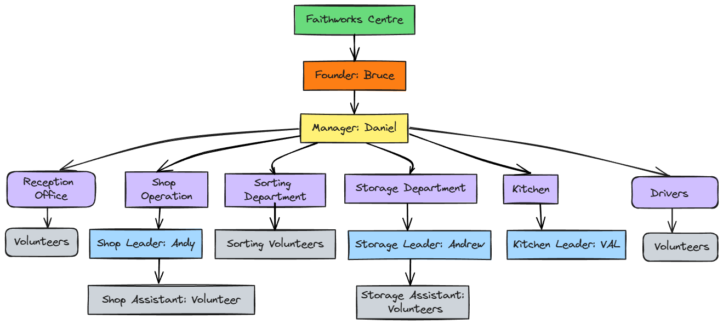

# **3.0 Current Business Processes**

Faithworks operates with a “faith-driven” motivation and the process management is highly informal and experience-based. Most processes are not formally documented; key knowledge resides mainly with Daniel and the founder Bruce. The processes are flexibly adjusted daily based on manpower, donation volume, and storage capacity, reflecting the unpredictable nature of operations. The main processes are:

1. Goods reception & Initial triage: Drivers collect and unload donated goods, which are immediately assessed and sent to relevant departments or storage areas.
2. Categorical Sorting & Quality Control: Volunteers inspect and re-select donated fruits and vegetables. Only items that meet quality standards are placed on store shelves.
3. Strategic Storage & inventory Allocation: Donated goods are categorised by expiry date and type. Staff decide whether to store, discard, or move items for sale, using different storage rooms as needed.
4. Meal Preparation Process: The kitchen team prepares meals from available donations for same-day sale in the store.
5. Retail Operations
6. Customer service and checkout process

Faithworks relies on a simple membership system and manual operations, lacking automation and standardisation (Fredericks & Seymour, 2022). Overall, process management is highly flexible and driven by individual judgment.

# **4.0 Current BPM Practices & Lifecycle Analysis**

From the interview with Daniel, it was clear that the BPM practices in the organization right now are informal, and operations are led by adaptability on ground. The following table narrates the BPM lifecycle management at present.



Table 1: Current BPM practices and lifecycle phase

# **5.0 Critical Process Selection**

The selected processes are Customer Service & checkout, and the combined process of Categorical Sorting and Quality Control, and Strategic Storage & Inventory Allocation. These processes were chosen because they are highly manual, unique to Faithworks, and important for service delivery. There lies a big opportunity for the company to become more efficient if these processes are streamlined.

The current Checkout process involves complex manual tracking of purchase-linked free goods giveaways which we aim to automate. Additionally, the sorting and storage process are closely linked and unifying them under one process will streamline accountability and improve efficiency.

# **6.0 Current Process Analysis (As-Is)**

## **6.1 Process 1: Categorical Sorting and Quality Control, and Strategic Storage & Inventory Allocation.**

### **6.1.1 Process Overview**

Faithwork’s storage and handling of donated goods starts with the receipt of donations. After suppliers donate goods, the transportation department collects and delivers them to the organization, where unloading and preliminary inspection take place. This stage initiates an end-to end process flow of a series of manual activities – sorting, quality checking, and allocation across multiple departments.

### **6.1.2 Initial Sorting and Categorization**

After arrival, staff first sort all donated goods into household items, non-perishable goods, kitchen supplies, and perishable goods. Household and non-perishable items are routed directly to the dry goods storage area, while kitchen-related goods are sent to the Meal preparation department for immediate use.

### **6.1.3 Strategic Storage and Expiry Management**

Perishable goods such as fruits and vegetables are sent to the sorting department for a detailed quality inspection. Items meeting quality standards are repackaged and moved to the store for sale; those failing to meet the standards are discarded.

The storage department receives most other goods and check their expiration dates. Meat that has past its “best before” date is moved to the animal-feed freezer, while other goods are placed outdoors in the yard for free collection. Non-expired goods undergo further categorization: for example, meat is placed in the freezer, dairy products are prepared for direct sale, and other goods are allocated between the main store freezer and storage freezer, depending on storage capacity and projected sales.

### **6.1.4 Preparation for Sale and Store Transfer**

After receiving the ingredients, the Meal Preparation department prepares and repackages goods into lunch boxes for same-day sale in store. All items ready for shelving – whether processes by the storage, sorting, meal preparation departments are all sent to the store by operations department.

### **6.1.5 Inventory Monitoring and Process Control**

The staff also conducts regular inspections of current inventory, flexibly adjusting the handling of goods based on inventory status and sales strategies as confirmed by the interviewee. Items not meeting conditions will be promptly removed or rearranged.

### **6.1.6 BPM Opportunities & Challenges**

This as-is process ensures Faithworks can efficiently handle diverse donated goods and maintain operational flow. However, the manual, department-based tasks lead to repetition, frequent handovers, and inconsistent standards; all of which leaves large opportunities for optimization. An automated process will accurately divide tasks standardizing accountability, reduce redundancy, and streamline operations.

### **6.1.7 As-is BPMN diagram of Categorical Sorting and Strategic Storage Process**

.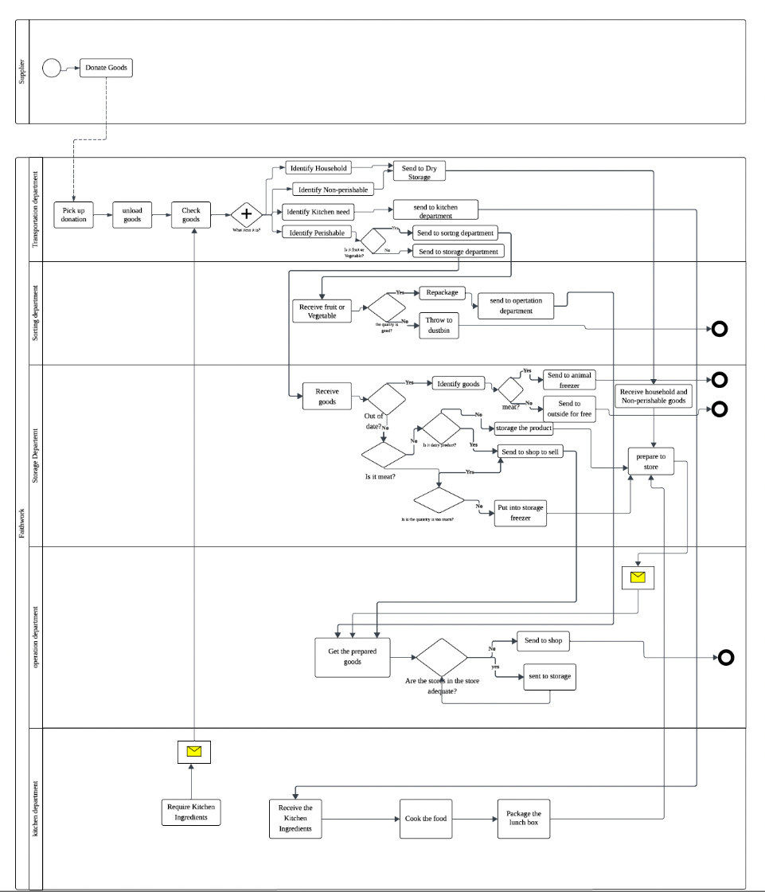

Diagram 1

## **6.2 Process 2: Customer Service & Checkout Process**

### **6.2.1 Customer Entry and Membership Verification**

The customer waits in line and makes their selections to start the process.  The cashier verifies their membership status when they arrive at the service desk.  The customer is prompted to join if they are not already a member.  A complimentary membership card is given to new members, and a $5 card replacement is available for those who misplace theirs.  Before continuing, cards are scanned and validated.

**6.2.2 Item Allocation and Conditional Pricing**

Members get three free items after verification.  A conditional pathway determines if the client has chosen vegetables.  Vegetables are weighed if so.  A community-friendly threshold pricing model is introduced, where a fee is only imposed if the weight surpasses two kilograms.  A total cost is determined for non-members or in situations that call for additional purchases.

**6.2.3 Payment and Receipt Issuance**

After that, customers pay with cash or a with credit card.  A receipt is provided following a successful transaction, and internal message flows are used to track the payment and totals.

**6.2.4 Yard Access and Social Inclusion**

As a last step, all customers are welcome to enter the yard and choose from a variety of complimentary items, further demonstrating the workshop's inclusive and encouraging goals.  In contrast to standard retail workflows, this socially embedded process places a strong emphasis on community access to free goods, conditional pricing for fairness, and membership engagement.

**6.2.5 As-Is BPMN diagram of Customer Service & Checkout Process**

Diagram 2

# **7.0 Proposed Process Analysis (To-Be)**

## **7.1 Process 1: End-to-End Barcode Enabled Stock Management**

The improved version of the categorical sorting and storage process begins when donated goods are collected by designated drivers who send digital pickup confirmation message to the suppliers as proof of collection. The process is then optimized using an Inventory Management System (IMS) that automates repetitive manual tasks (Chan, Ramiah, & Razali, 2023). Zoho IMS can be a perfect as it provides barcode inventory management, real-time tracking, and easy reporting.

### **7.1.1 Barcode Generation and Attachment (Sub-process)**

The driver records key details: expiry date, condition, and item type – into the IMS which generates a unique barcode for every stock palette. The barcode is printed and attached to goods and the driver confirms the task completion in the system via an app.

### **7.1.2 Goods Sorting and Barcode Scanning**

The sorting team scans each barcode to register goods into the IMS. If a scan fails, they retry once; after a second failure, the system flags the issue with the vendor for resolution within 24 hours. If unresolved, the legacy manual intake process is used. Successfully scanned barcodes enable the IMS to display and record all relevant data.

### **7.1.3 Log Scan Event: Goods Categorization and Allocation (Sub-process)**

The IMS automatically categorizes goods—perishable, non-perishable, household, or kitchen items—and applies business rules for handling. The sorting teams reviews the IMS’s recommendations: perishable items are checked for expiry and sale ability, non-perishables and household goods are assessed for condition, and kitchen items are matched to the updated kitchen requirements list which is checked against the weekly automated kitchen requirements checklist. After categorization, the sorting team allocates goods to either directly to the store, storage or meal preparation department. Ready meals are sent to the shop floor by the operations department, ensuring a cohesive and integrated workflow.

### **7.1.4 Role of Operations and Storage Departments**

After the sorting team organizes the goods according to the IMS’s recommendations, the items are handed over to the storage team who collaborates with the operations department to determine current shop floor stock needs. For household and non-perishable items, the storage team requests a list of required products from operations department. This communication is done through internal messaging systems. Based on this coordination, goods are dispatched either to the shop floor via the operations department or directed to storage as needed.

### **7.1.5 Kitchen Logging and Stock Automation**

Simultaneously, the meal prep department logs ingredient usage as meals are prepared. Every Friday at 3PM the system performs an automated stock update, producing a requirements list which is used during Goods categorization step to allocate stock to meal preparation department.

### **7.1.6 BPM Lifecycle Analysis of proposed process**

A comparison table of the As-Is vs. To-be processes are available in the appendix Under



Table 2

### **7.1.7 To-Be BPMN diagram of end-to-end barcode enabled stock process**

### **7.1.8 Barcode Generation and Attachment sub-process expanded**

Diagram 4

### **7.1.9 Log Scan Event: Goods categorization and allocation sub process expanded**

Diagram 5

## **7.1.10 Kitchen Logging and Stock Automation Process**

Diagram 6

## **7.2 Process 2: Digitally Assisted Customer Checkout Process**

The TO-BE BPMN diagram presents an optimized version of the customer checkout process at FaithWorks, designed to improve accuracy, speed, and service resilience. The process begins when a customer selects items and proceeds to checkout. The cashier scans the customer’s membership card to retrieve their profile and apply for eligible benefits. If the customer is not a member, they are offered registration, and their details are added to the membership system in real time.

### **7.2.1 Membership and Item Scanning**

Once membership is confirmed, the cashier scans items into the POS system (Chavan & Bhoite, 2024), which also handles the weighing of fruit and vegetables. If the weight exceeds the 2kg member allowance, the system automatically calculates an additional charge. This ensures fair distribution while reducing manual calculation errors. The system also automatically applies discounts, such as three free items for eligible members, eliminating inconsistencies previously caused by human judgment.

### **7.2.2 Payment and Exception Handling**

Payment is processed through integrated cash or card systems. If the card is declined or system errors occur, exception handling ensures a fallback to manual payment via a calculator or handwritten receipts. After a successful transaction, the system checks whether the receipt printer is operational. If it is, a printed receipt is provided. If not, the receipt is sent digitally to the customer’s phone number.

### **7.2.3 Post Checkout Service**

Customers are then invited to visit the outdoor yard for additional free items. Overall, the TO-BE process provides traceability, consistency, and scalability, while supporting community values and service transparency.

### **7.2.4 BPM Alignment & Flexibility**

This process is aligned with best practices in business process management (BPM), which emphasize automation, exception handling, and resource orchestration to ensure robustness and efficiency (Dumas et al., 2018). The diagram includes realistic decision gateways to manage system failures or customer-specific conditions. By integrating systems while maintaining manual fallbacks, the design achieves both flexibility and reliability—principles core to sustainable process redesign.

### **7.2.5 To-Be BPMN diagram of Digitally Assisted Customer Checkout process**

### Picture 1304801917, Picture  **7.2.6 Expanded Sub-Process**

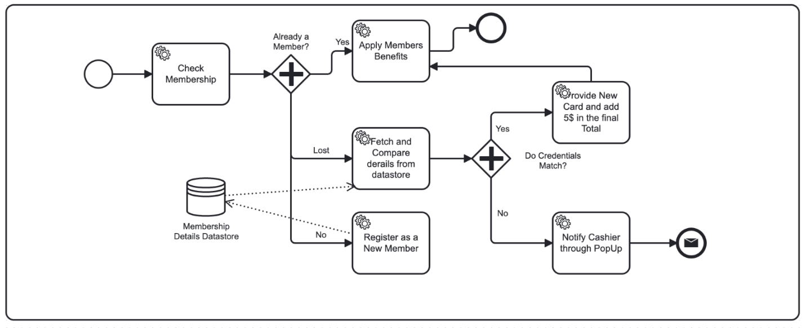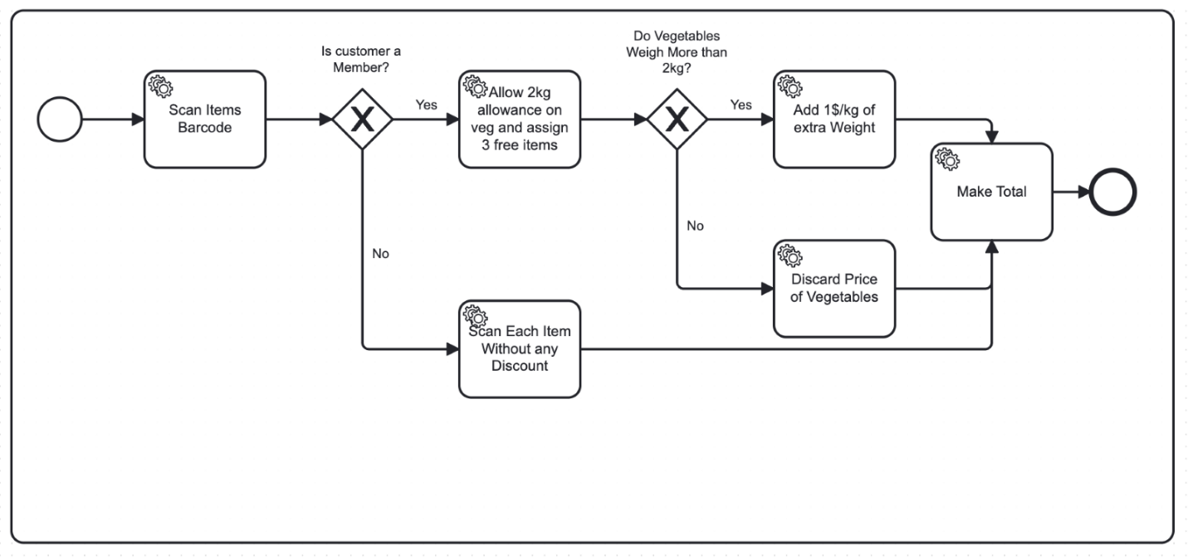

# **8.0 Business Process Improvement Perspectives**

Faithworks’ process improvements will benefit staff, technology, efficiency, and lean operations – while also reducing costs over time. Detailed analysis is provided in the appendix section under Table 1, section 1.1.

# **9.0 Business Specific Recommendations**

Based on the process analysis and the company’s unique challenges mentioned by Daniel in the interview, we made several targeted recommendations to help Faithworks improve efficiency and increase operational scalability. A detailed breakdown is provided in the appendices under section 1.2.

# **10.0 Conclusion**

This report combines the findings from the interview with Daniel the store manager of Faithworks, their AS-IS process and TO-BE recommendations, and improvement plan analysis. We identified and investigated the bottlenecks in the two key processes of Categorical sorting and storage of inventory and customer checkout process. The study proposes lightweight digital improvement plans such as barcode inventory, IMS integration, POS system with extended features such as discount calculation and more to reduce manual decision-making nodes and reduce customer waiting time expectations by about. The tools used in this plan are low-cost, suitable for phased advancement, and the technical and organizational risks are controllable. Its goal is consistent with the organization's goal of "serving vulnerable groups faster", and it is recommended to carry out small-scale pilots as soon as possible and continue data-driven improvements.

# References

Azhari, F. N., & Sutarman, S. Transforming SME operations with real-time mobile POS and Firebase integration. International Journal of Science, Technology, Engineering and Mathematics, 4(4), 108-135. <https://doi.org/10.53378/ijstem.353134>

Brown, D. (2025, May 6). *Group interview on Faith Works business operations and processes*.

Chan, C. W., Ramiah, S. A. P., & Razali, N. F. (2023). Inventory Management Systems (IMS). *Journal of Applied Technology and Innovation, 7*(3), 13–20. <https://www.researchgate.net/profile/Nurul-Farhaini-Razali/publication/372653862_Inventory_Management_Systems_IMS/links/64c1e3f695bbbe0c6e60fea0/Inventory-Management-Systems-IMS.pdf>

Chavan, S., & Bhoite, S. D. (2024). *Cloud-powered retail management study: Elevating business operations with cloud-based POS solutions over in-house POS*. *CSIBER International Journal (CIJ)*, 2(2), 1–9. <https://siberindia.edu.in/journals/CIJ/Apr-24/Paper4.pdf>

Dumas, M., La Rosa, M., Reijers, H. A., & Mendling, J. (2018). *Fundamentals of Business Process Management* (Second edition). Springer Nature. <https://doi.org/10.1007/978-3-662-56509-4>

Fredericks, C., & Seymour, L. F. (2022). *Understanding process management in non-profit organisations without formal business process management*. In J. Gulden, R. Schmidt, & H. A. Reijers (Eds.), *Enterprise, business-process and information systems modeling* (pp. 79–87). Springer. <https://doi.org/10.1007/978-3-031-07475-2_6>

Wohed, P., van der Aalst, W. M. P., Dumas, M., ter Hofstede, A. H. M., & Russell, N. (2006). On the suitability of BPMN for business process modelling. In S. Dustdar, J. L. Fiadeiro, & A. Sheth (Eds.), *Business Process Management: BPM 2006. Lecture Notes in Computer Science* (Vol. 4102, pp. 161–176). Springer. <https://doi.org/10.1007/11841760_12>

Azhari, F. N., & Sutarman, S. Transforming SME operations with real-time mobile POS and Firebase integration. International Journal of Science, Technology, Engineering and Mathematics, 4(4), 108-135. <https://doi.org/10.53378/ijstem.353134>

Huchzermeier, A., Wolters, J., & Uphues, M. (2023). Case article—The RealPro customer benefits program: Rekindling shopper loyalty through a subscription service. INFORMS Transactions on Education, 24(1), 17-21. <https://doi.org/10.1287/ited.2021.0257ca>

# **Appendices**

## **1.0 Report Extensions**

### **1.1 Business Process Improvement Perspective**

|  |  |  |
| --- | --- | --- |
| Improvement Perspective | Detailed Analysis for Faithworks | Cost Analysis |
| People | By automating repetitive calculations and standardizing procedures, staff and volunteers at Faithworks will experience reduced stress and lower risk of error. This allows them to focus on genuine customer service and community engagement, while also easing training and onboarding. | The main costs include time and resources for staff training and change management, but these are offset by faster onboarding and improved staff retention. |
| Technology | Implementing an integrated IMS and POS system will bring transparency and traceability to inventory and transactions, enabling real-time tracking, digital reporting, and robust fallback protocols—critical gaps Daniel highlighted in the interview. | Initial investments will be needed for software licenses, barcode scanners, and POS hardware, along with annual maintenance fees. However, this investment is justified by gains in accuracy and the prevention of lost or untracked goods. |
| Process Efficiency | Automated scanning, weighing, and digital record-keeping will streamline workflows and minimize manual bottlenecks. Staff can process transactions and restocking more quickly and with fewer mistakes, directly supporting Faithworks’ high service volume. | Process efficiency translates into long-term savings through reduced waste, lower error rates, and less time spent on manual corrections. This also allows Faithworks to serve more clients without increasing headcount. |
| Lean Approach | By eliminating redundant steps and centralizing information, Faithworks will reduce waste, better align inventory with actual demand, and support “just-in-time” stock management. This makes the entire process more agile and resilient. | Lean improvements require upfront system configuration and process mapping, but produce ongoing savings by reducing spoilage, minimizing excess inventory, and improving resource allocation. |

### **1.2 Business Specific Recommendations**

Based on the process analysis and the company’s unique challenges mentioned by Daniel in the interview, we made several targeted recommendations to help Faithworks improve efficiency and increase operational scalability.

1. Implement an integrated IMS and POS system:

We have recommended that Faithworks invest in an IMS that integrates point-of-sale (POS) functions that can automatically calculate discounts. This will centralize inventory, automate member tracking, and provide transparent real-time data for decision-making, which can make up for the current shortcomings in process documentation and manual supervision (Azhari & Sutarman, 2024).

2. Standardize and document core processes:

Document all key operational steps, from inventory to inventory to checkout, and create clear and easy-to-understand guides for employees and volunteers. At the moment it is all present in the store manager’s head which has been mentioned in the interview with Daniel.

3. Automate eligibility and benefit applications:

In the long run, Faithwork can also adopt new technologies to automate member benefit checks, discount and free product eligibility reviews, and reduce manual errors.This will improve customer experience and consistency in operations (Huchzermeier et al., 2022) as there is potential to go big.

4. Enhance staff training and change management:

Organizations can provide structured training on new systems and processes. Through regular feedback sessions and open communication, help staff and volunteers make the transition and recognize Faithworks’ reliance on the volunteer base.

5. Continuous monitoring, review, and improvement:

It is recommended that Faithworks uses IMS analytics tools to monitor operations. They can establish a regular review system to reduce the risk of processes deviating from Faithworks’ mission and adjust as needs change.

## **1.3** **Comparison table As-Is vs. To be process 1: Categorical Sorting and Storage of Inventory**

|  |  |  |
| --- | --- | --- |
| Process Steps | As-Is Process | To-Be Process |
| Data Entry | Manual, undocumented; relies on staff memory | Digital entry by driver; barcode with key info generated and recorded in IMS |
| Goods Tracking | Paper-based or verbal; high risk of loss | Barcodes ensure digital traceability at every stage |
| Error Handling | Ad hoc, not systematically tracked | Barcode scan errors flagged and resolved with vendors; fallback to manual only if unresolved |
| Sorting/Categorization | Manual sorting by category and quality; repetitive and subjective | Automated categorization in IMS, with sorting team reviewing and confirming |
| Inventory Control | Visual and manual checks; inventory status updated irregularly | Automated stock updates and real-time inventory monitoring via IMS |
| Kitchen Requirements | Ingredient usage tracked manually or verbally | Digital logging; automated requirements list generated weekly and refined by kitchen staff |
| Allocation | Staff decide on storage and allocation, often with duplicated effort across departments | IMS suggests optimal allocation based on rules; team verifies, reducing duplication and manual intervention |
| Accountability | Spread across departments; little standardization or documentation | Integrated, auditable, and standardized process with clear system logs and responsibilities |
| Efficiency | Prone to delays, errors, and inefficiencies due to manual repetition | Streamlined, automated, and error-minimized through technology |
| Transparency | Limited process visibility; difficult to audit or analyze | Full visibility and audit trail available through the IMS |

## **1.4 Comparison table As-Is vs. To be process 2: Digitally Enabled Checkout process**

|  |  |  |
| --- | --- | --- |
| Process Step | AS-IS Process | TO-BE Process (Improved) |
| Membership Verification | Manual check or verbal confirmation by staff | Scanned membership card linked to system; auto-verifies or allows instant registration |
| Free Item Eligibility | Staff rely on memory to apply 3 free item rule for members | System automatically applies eligibility rules based on member status |
| Produce Weighing | Manual weighing and price calculation by staff | Integrated digital scale connected to POS auto-calculates and applies over-limit charge |
| Item Scanning | Items may be manually totaled or guessed; risk of omission | All items scanned through POS; totals calculated automatically |
| Payment Handling | Payment done in cash or basic card reader; manual change calculation | POS accepts cash/card; calculates change; logs transaction digitally |
| Receipt Generation | Manually written or sometimes skipped | Printed or digitally sent receipts; fallback included for printer failure |
| Fallback Handling | Minimal fallback; disruptions handled ad hoc by staff | Defined exception handling: manual process steps if systems fail |
| Transaction Logging | No systematic logging or reporting | All transactions logged in POS/database for reporting and audit |
| Customer Queue Handling | Single line; high dependency on staff speed | Faster checkout with reduced bottlenecks via system automation |
| Fairness & Transparency | Prone to inconsistency in applying rules | Benefits applied uniformly based on system logic and membership data |

## **2.0 Interview Proof**

|  |  |
| --- | --- |
| 1. Selected Organisation and Industry | FaithWorks; Retail and Hospitality Industry |
| 2. Interviewee Name | Mr. Daniel |
| 3. Interviewee LinkedIn Profile | N/A (Discussed with lecturer over email regarding this) |
| 4. Company website | <http://www.assist.net.au/> |
| 5. Interview Arrangements | The interview was held over Zoom. |
| 6. Interview Video Link | [https://www.youtube.com/watchv=FlpxaYbjEcw](https://www.youtube.com/watch?v=FlpxaYbjEcw) |
| 7. Interview Questionnaire | [BPM Interview Final Questions.docx](https://mymailunisaedu-my.sharepoint.com/:w:/g/personal/luoly016_mymail_unisa_edu_au/EX1aDyUQOa5JicAFK31mdQ4BuXqMev-6IF2VJEB4y7UkSw?e=tPmTNU) |
| 8. Interview Transcript | [Final_Transript.docx](https://mymailunisaedu-my.sharepoint.com/:w:/g/personal/luoly016_mymail_unisa_edu_au/EdsMFkHTrcNGinWe0PlSQbgBWTBnpCrza09qmFRQUsAOOA?e=HlorjL) |